* GO TO CHROME AND OPEN REMIX PLATFORM

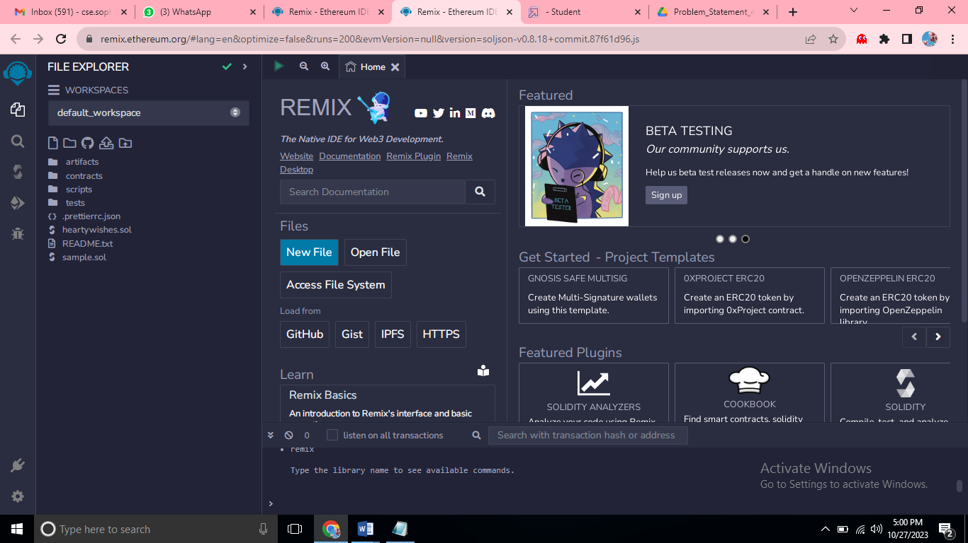

* THE REMIX PAGE AND CREATE A NEW FILE

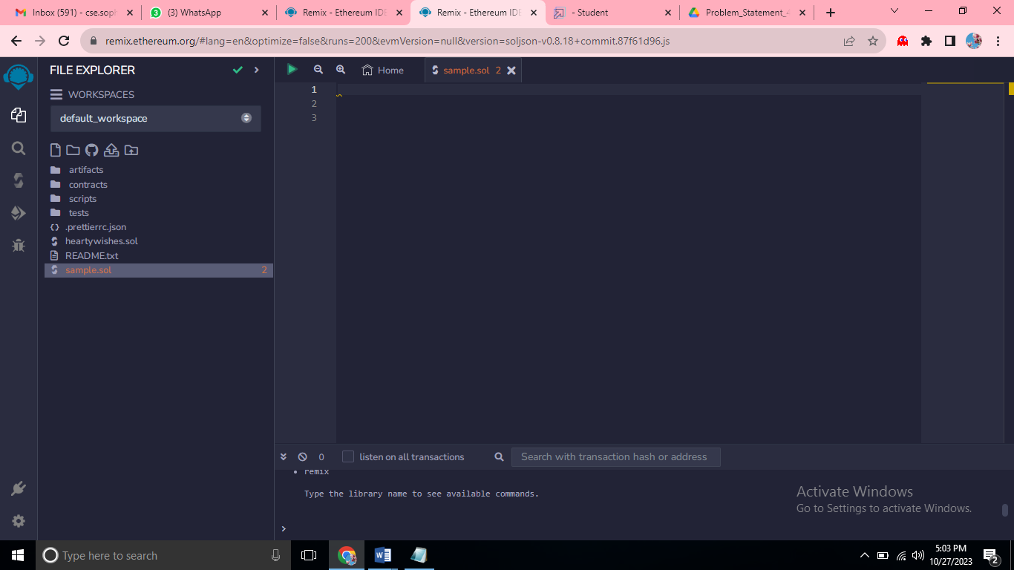

* IN THAT NEWLY CREATED FILE,CREATE A PROGRAM TO RETURN YOUR STRING,”ZONE NAME”

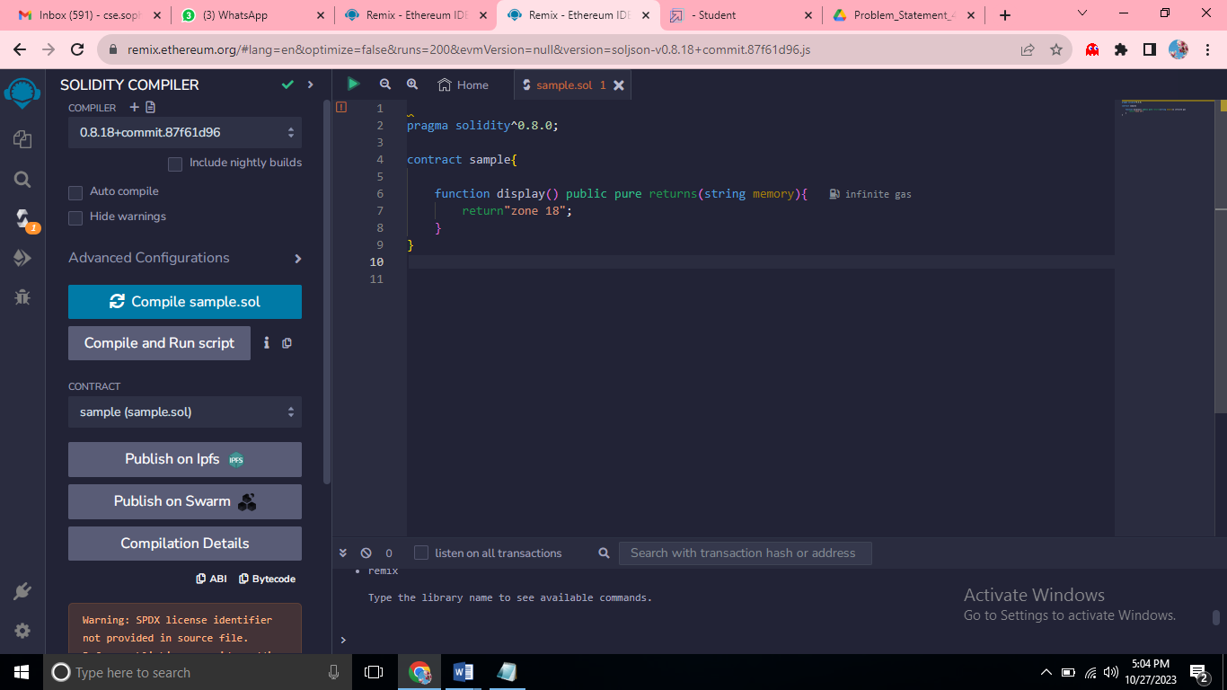

* SAVE THE PROGRAM AND COMPILE IT TO GET ABI AND BYTECODE

[

{

"inputs": [],

"name": "display",

"outputs": [

{

"internalType": "string",

"name": "",

"type": "string"

}

],

"stateMutability": "pure",

"type": "function"

}

]

Bytecode



FINALLY DEPLOY IT TO DISPLAY THE OUTPUT

